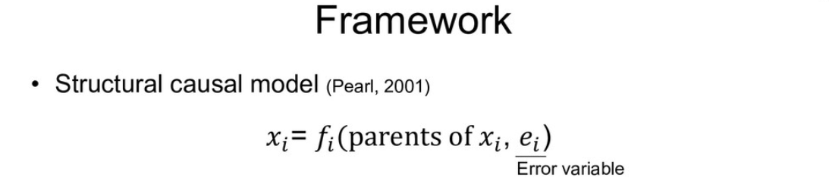

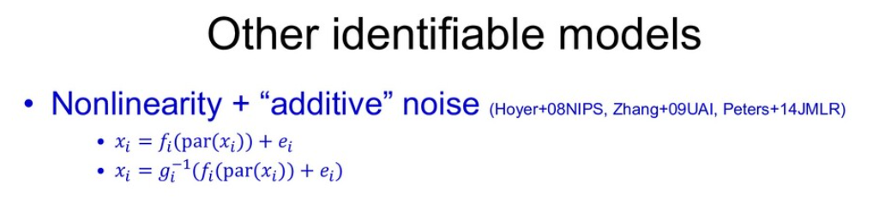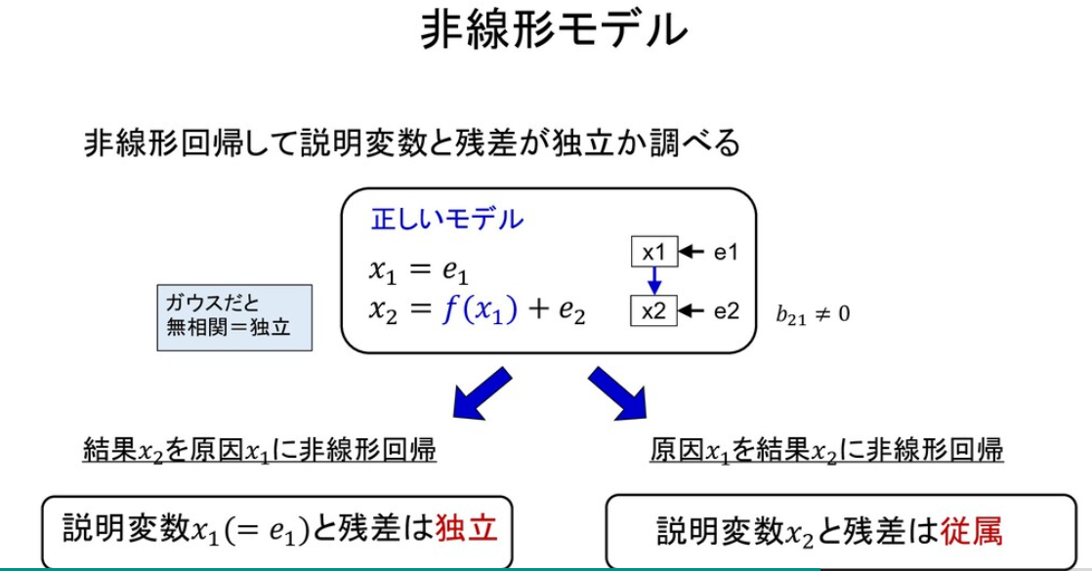

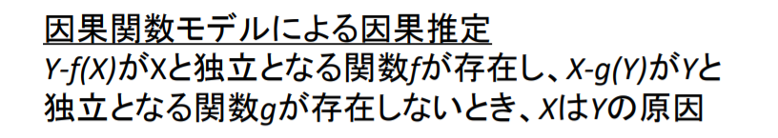

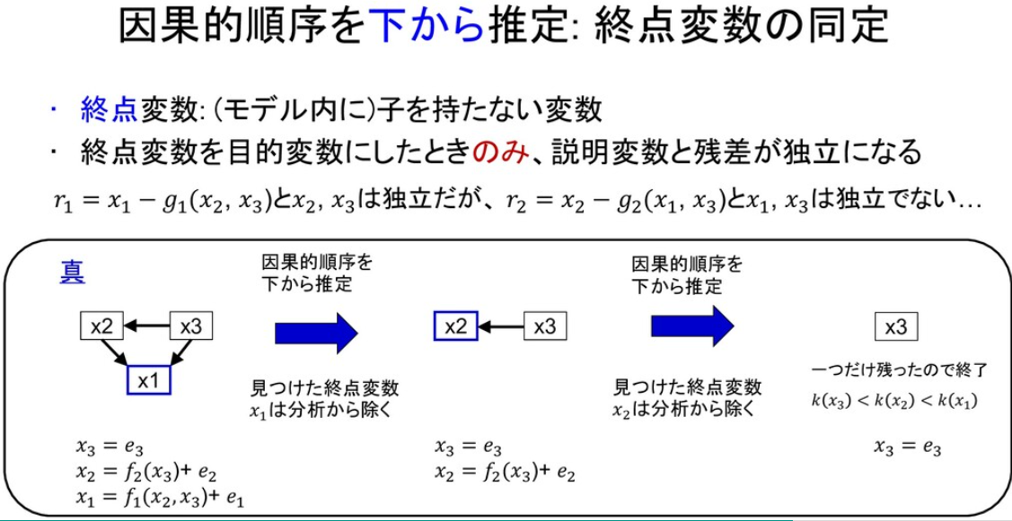

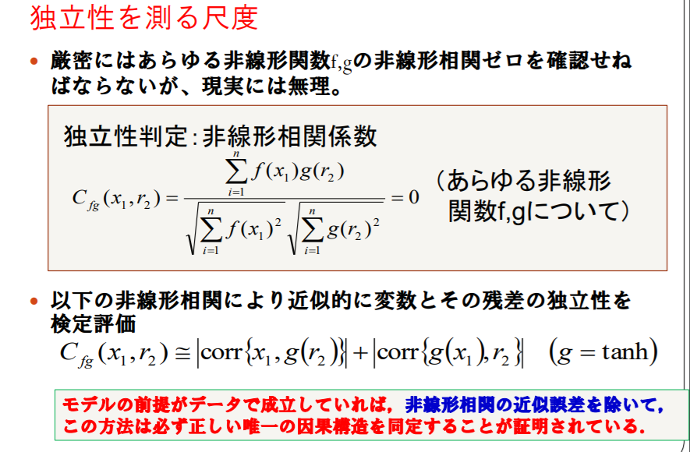

<https://ibisml.org/archive/ibisml001/2010_IBISML01_Washio.pdf>

<https://www.sas.com/content/dam/SAS/ja_jp/doc/event/sas-user-groups/usergroups2015-g-01.pdf>

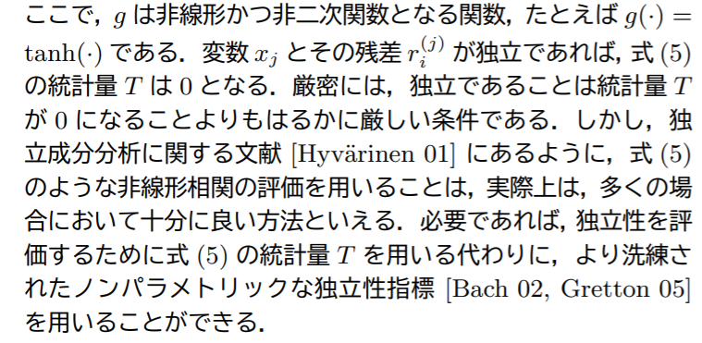

<http://www.ar.sanken.osaka-u.ac.jp/~inazumi/Inazumi10JSAI.pdf>

<https://www.mathsoc.jp/publication/tushin/1604/1604washio.pdf>

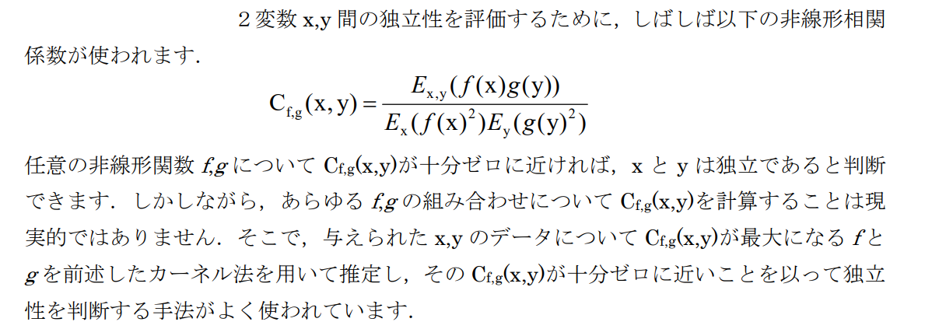

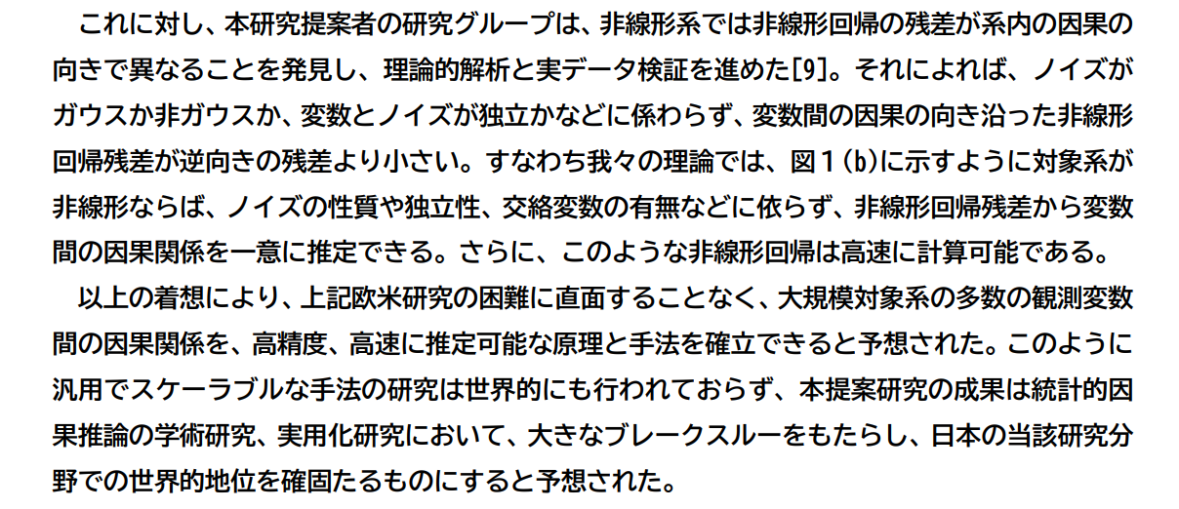

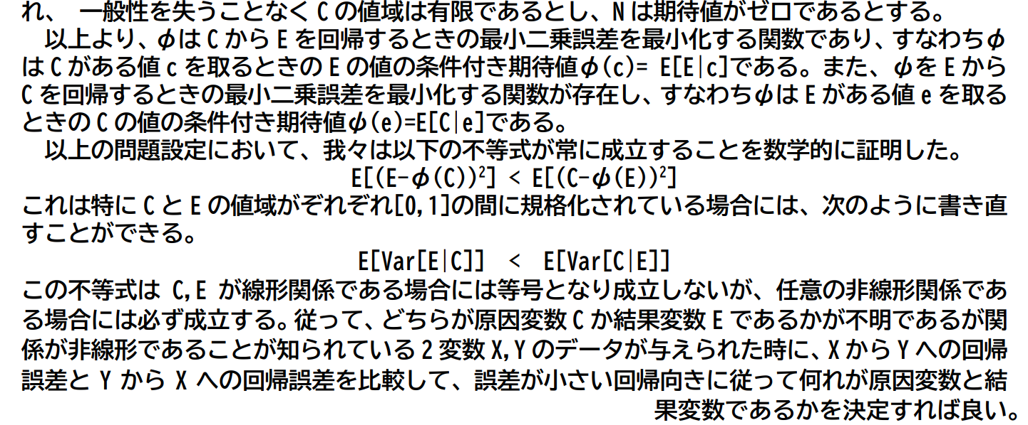

<https://kaken.nii.ac.jp/file/KAKENHI-PROJECT-17K00305/17K00305seika.pdf>

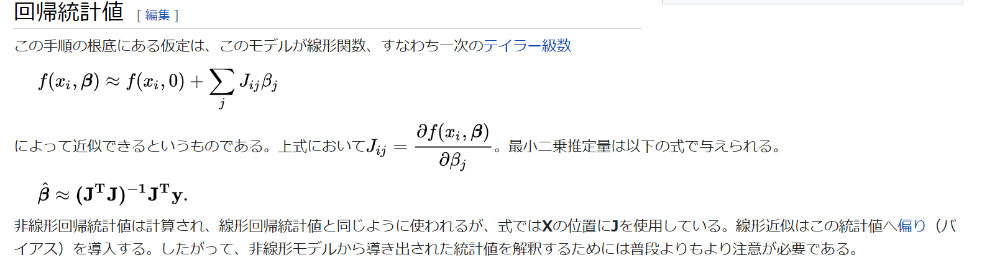

<https://ja.wikipedia.org/wiki/%E9%9D%9E%E7%B7%9A%E5%BD%A2%E5%9B%9E%E5%B8%B0>

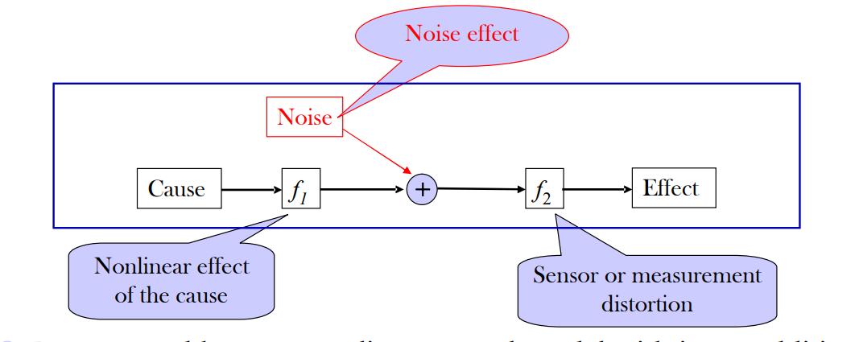

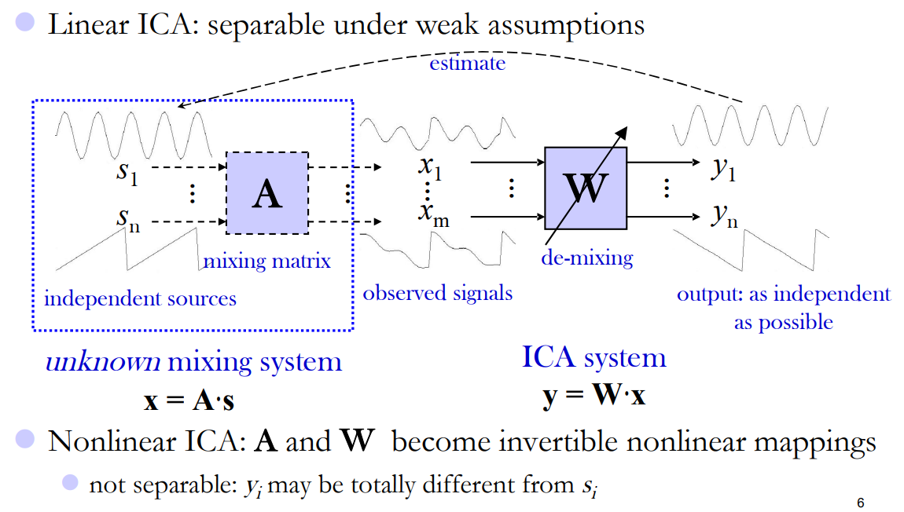

<http://clopinet.com/isabelle/Projects/NIPS2008/slides/Zhang_nips08_causality_slides.pdf>

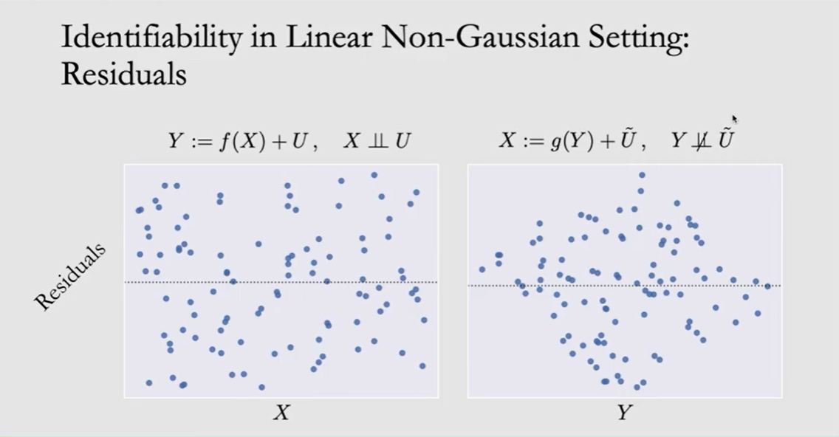

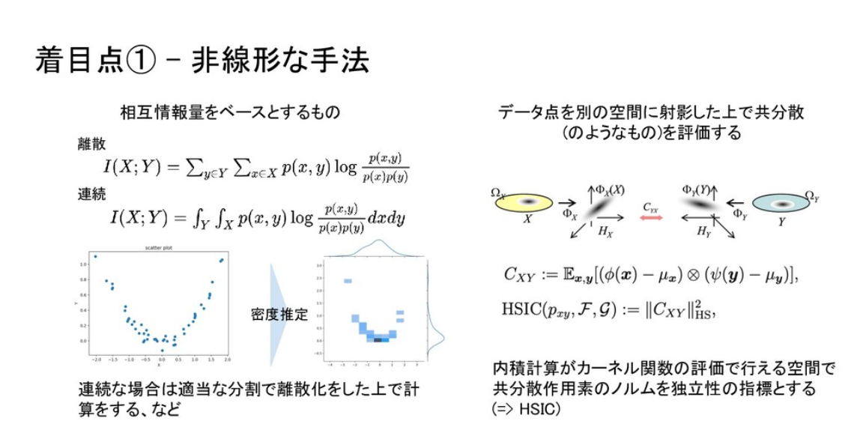

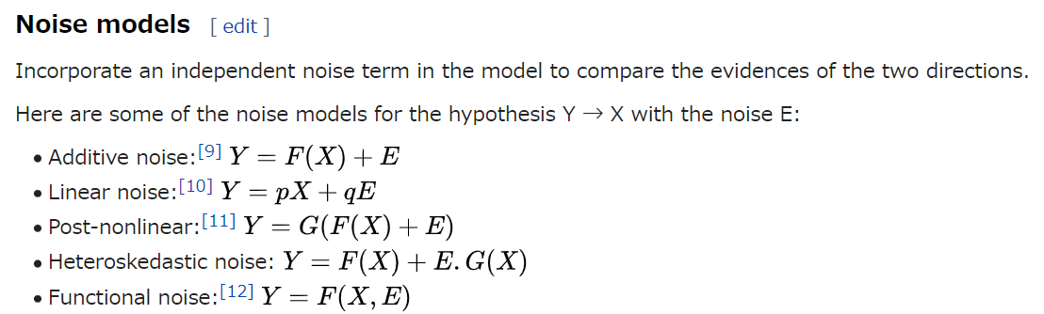

<https://en.wikipedia.org/wiki/Causal_inference>

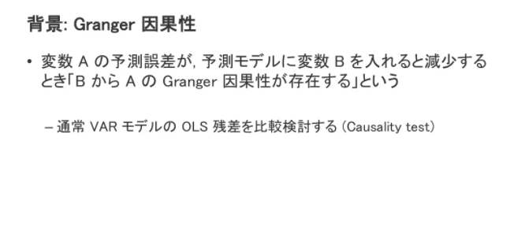

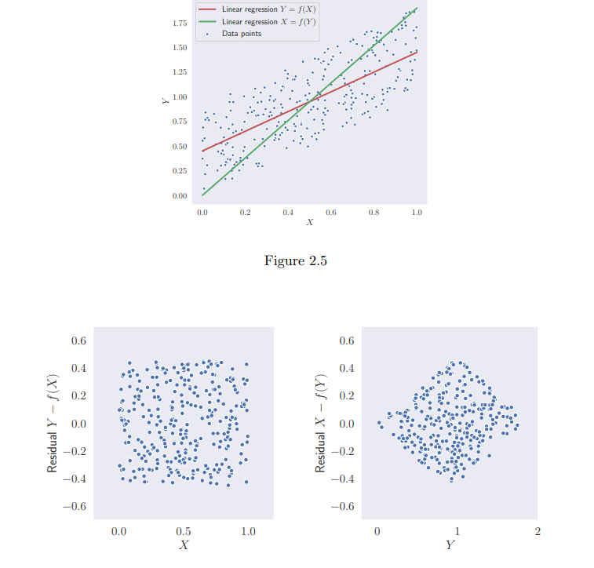

<https://hal.inria.fr/tel-02435986/document>

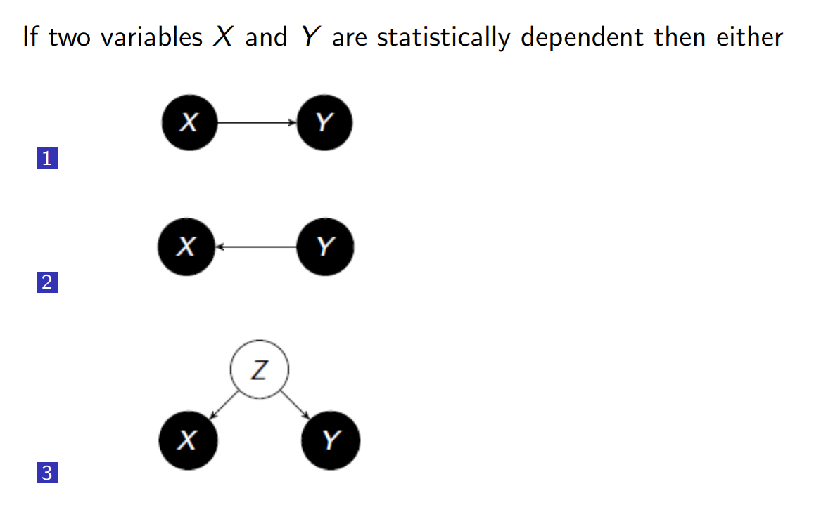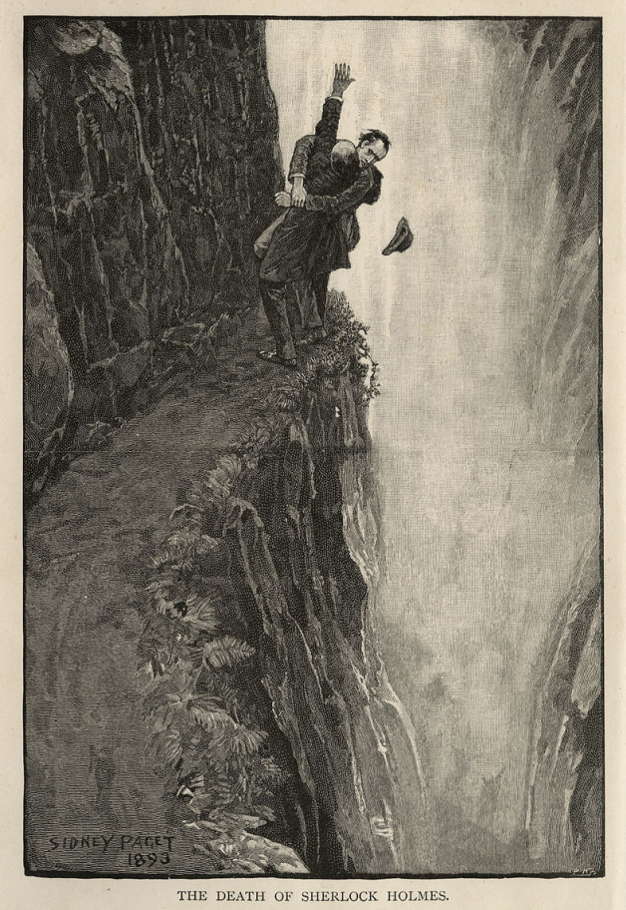

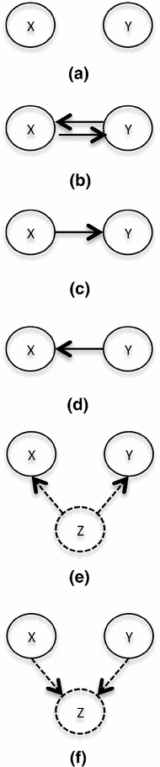

[Tell cause from effect: models and evaluation](https://link.springer.com/article/10.1007/s41060-017-0063-0)

http://www.ar.sanken.osaka-u.ac.jp/~sshimizu/papers/JJSS08.pdf

観測変数を標準化しておくことも, 尺度不変になりよいと思われる.

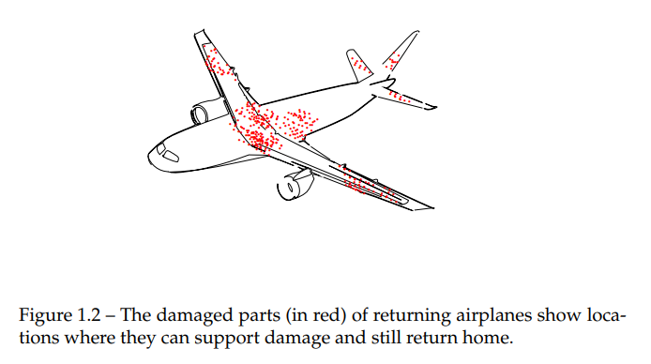

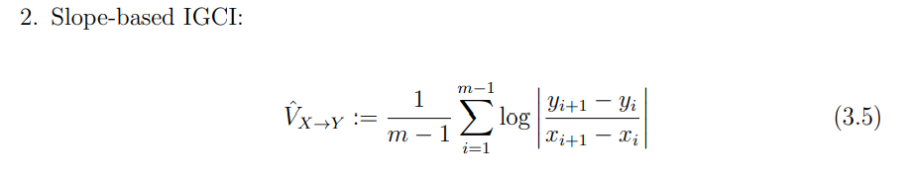

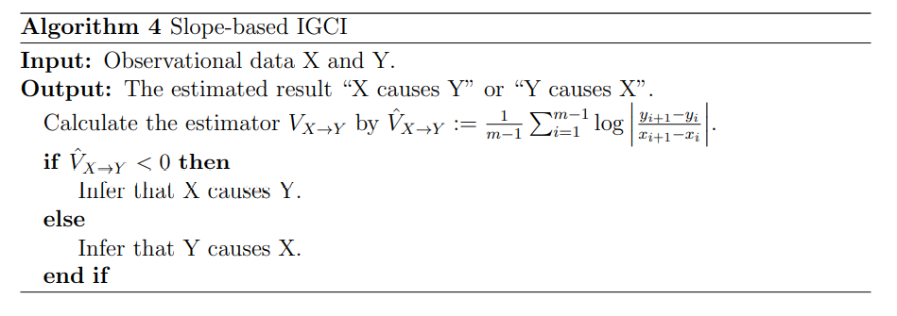

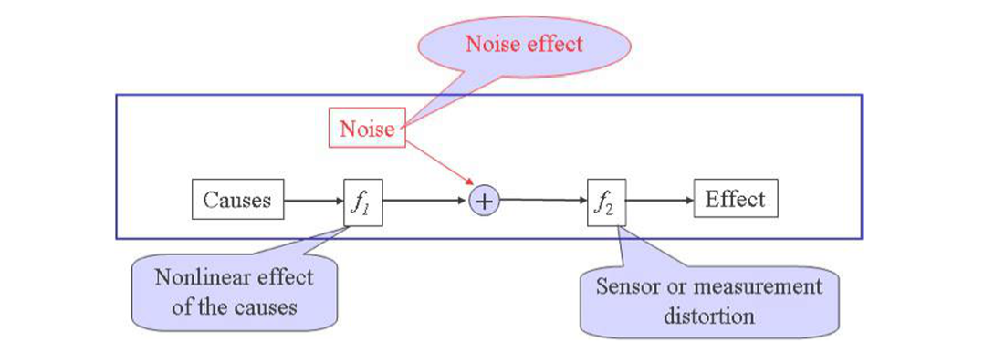

chrome-extension://efaidnbmnnnibpcajpcglclefindmkaj/https://cra.org/ccc/wp-content/uploads/sites/2/2016/11/Slides_AAAI_symposium16.compressed.pdf